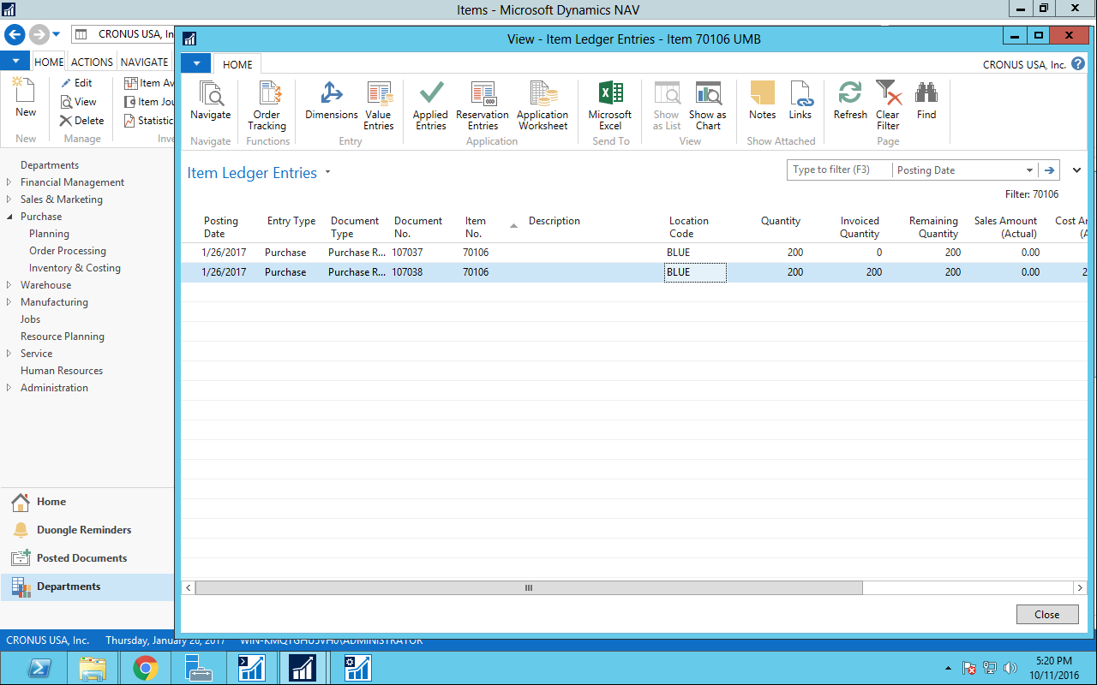

I made 2 order for a better compare.

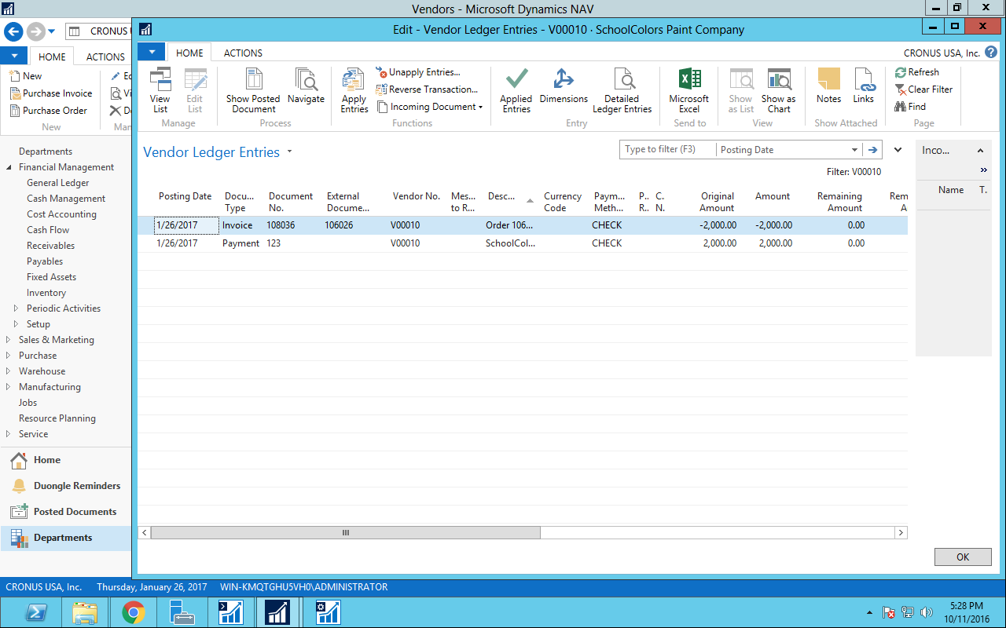

Vendor balance (Vendor Ledger Entries)